Position Description: Chief Financial Officer of St. Edward High School (starting 2022-2023 school term)
Reports to: School President

Background: St. Edward High School (SEHS) is a premier private boys’ Roman Catholic college preparatory high school in Lakewood, Ohio, just west of Cleveland. The School was founded in 1949 and is operated in the tradition and charism of the Congregation of Holy Cross and sponsored by the Brothers of Holy Cross Midwest Province. The School has an enrollment of 900+ students from a variety of race, economic, and religious strata, with a six-county geographic reach.

Mission: SEHS’s mission is to educate the hearts and minds of a diverse group of young men to have the competence to see and the courage to act as men of hope for the transformation of the world.

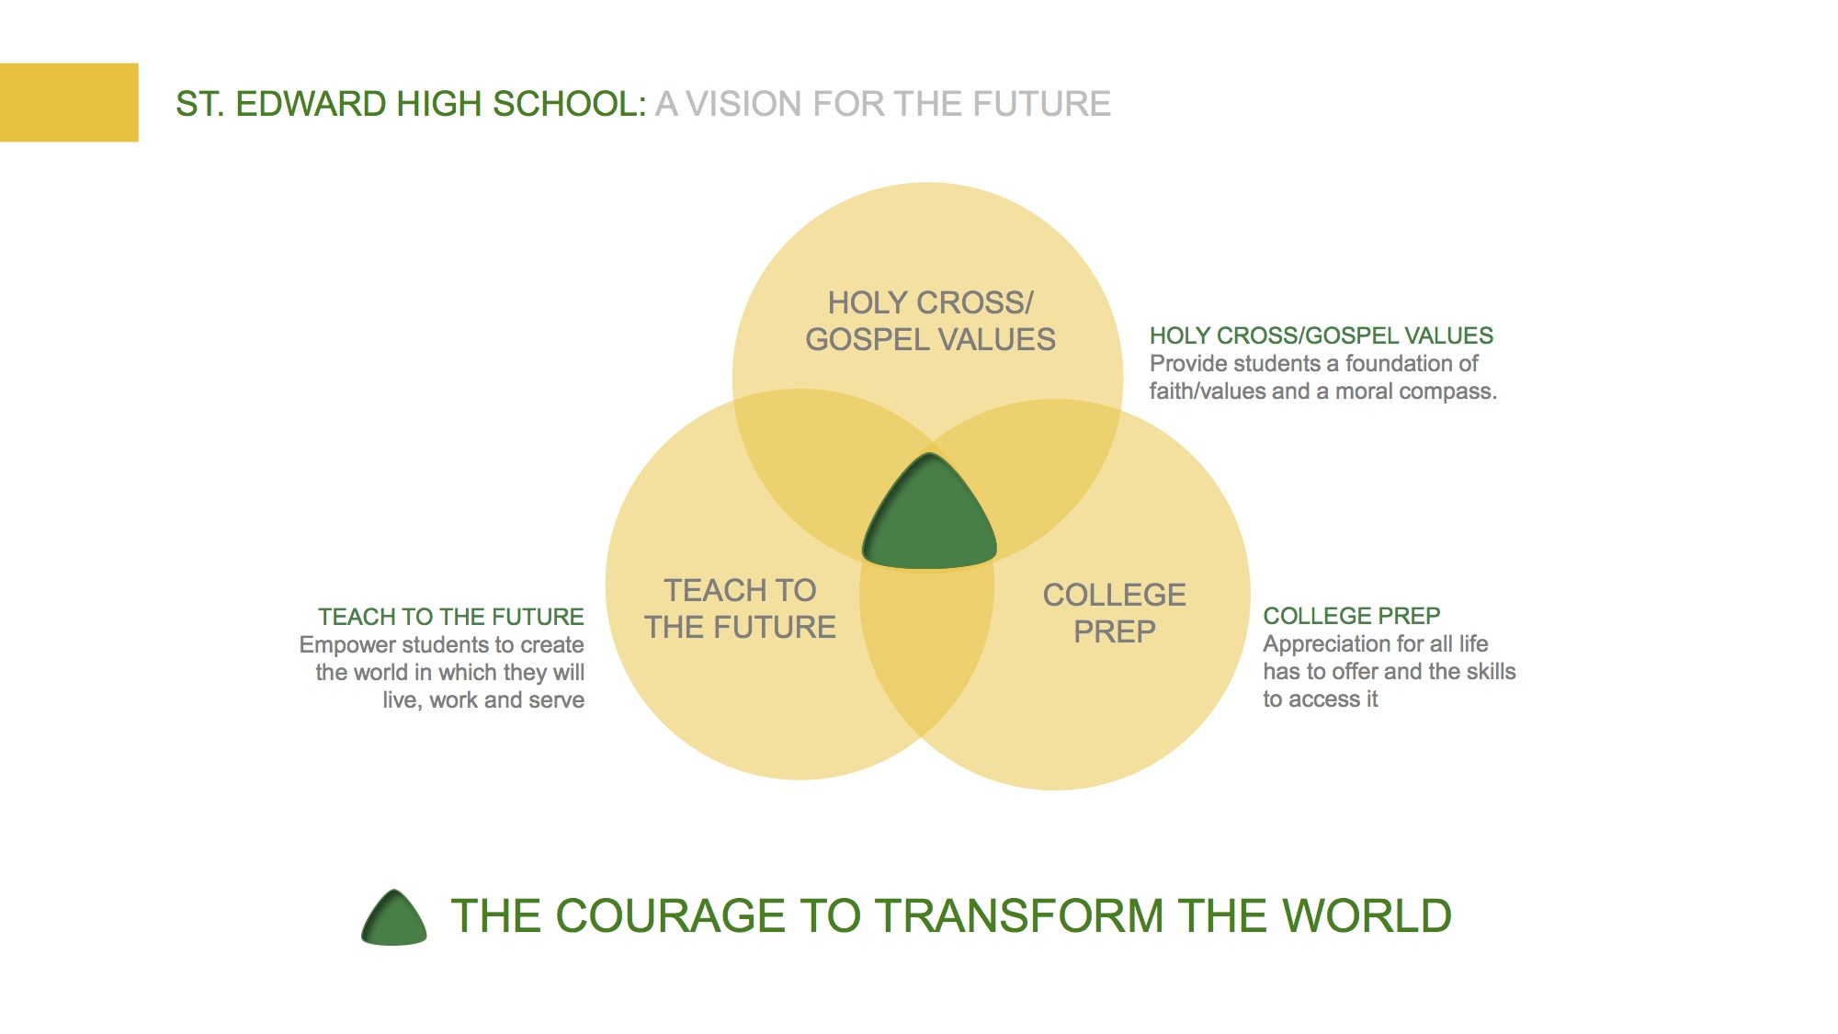

The School is known for its strong, nurturing community that emphasizes cultural humility and hospitality. Our work is centered around four pillars: Faith formation, Excellence, Relationships and Servant leadership.

Position Summary: The CFO supports the St. Edward HS Mission through appropriately maintaining and advising the school President and school Board of Trustees on the financial and budget matters of the school and administration of the school’s finances in compliance with federal, state, and local laws. The CFO sets and oversees the strategic direction for the Finance Team, Human Resource Director and Associate Vice President of Building and Grounds.

Primary/Essential Responsibilities: (not all-encompassing)

Financial Planning & Control
- Understands and supports the Mission, standards and policies of St. Edward HS, contributing to their formation, evaluation and administration.
- Keeps the school President and Board of Trustees informed as to the financial condition of the school.
- Prepares financial and budget statements, investment and capital project expenditures for review by the school President, Finance Committee and Board of Trustees.
- Working with school leadership creates a comprehensive school security plan which includes confidential data and physical safety of employees and students. Supervises the implementation of the plan.
- Prepares and analyzes financial information providing direction and support on expenditures, making recommendations on investments, maximizing use of school funds and ensuring budget compliance.
- Maintains a variety of manual and electronic fiscal data files and records ensuring an accurate audit trail and audit compliance, forecasts future expenditures and ensures school funds are allocated accurately.
- Responsible for developing and maintaining banking relationships, managing the debt of the school, ensuring timely payments and compliance with all covenants and borrowing agreements.
- Oversees all activities designed as Business Office responsibilities including financial controls, physical plant and grounds, risk management and insurance, school vehicles and transportation, employee compensation and HR policy, along with accounting and operations procedures.

ACCOUNTING
- Establishes and sustains procedures and appropriate controls for all financial systems in accordance with IRS, FASB, SEC and Diocesan standards, along with the supervision of finance employees.
- Final responsibility for Business Office activities, G/L, accounts payable and receivable, expense reimbursement, cash, financial aid awards and administration, payroll processing and associated tax filings, contributions to retirement plans, and accounting systems, processes and procedures.
- Participate with independent audit, taking are of bad debt and any legal contingency matters.
- Maintain working relationship with independent auditors, supervising data provided to auditors, and responding to and implementing auditor’s recommendations.
- Ensuring compliance with all government regulations including but not limited to IRS reporting, fire/health and building inspections and EPA regulations.
- Establish and oversee internal audit procedures for financial, accounting and IT systems.
- Manages the creation of all financial reporting and financial statement creation, including the tax-exempt return and any payroll and retirement saving returns required.
- Oversees Auxiliary funding programs providing financial modeling and reporting of auxiliary expenditures.

BUDGET
- Prepares the preliminary annual budget, collaborating with the school President, Cabinet members and department chairs responsible for budget. Submits budget proposal to the Finance committee for comments and initial approval, then to the Board of Trustees for final approval.
- Working closely with the school President, Board members and Cabinet members creates and maintains the school’s current operating budget, and establishing 3yr. and 5 yr. initiatives.
- Sets and directs the process for ensuring all school expenditures are within budget and that substantial deviations are approved by school administration prior to expenditure.

RISK MANAGEMENT
- Evaluates and selects insurance contracts to maintain adequate comprehensive, property, liability and Director’s and Officer’s insurance coverage.
- Coordinates compliance with OSHA, Ohio and Cuyahoga Departments of Health, Lakewood police and fire, and other agencies as required.

TUITION
- Drives the strategic direction for all matters related to student’s tuition, including the setting and collection of tuition and fees.
- Sources new grant offering and keeps abreast of all grants and their administration related to Catholic school tuition. Looks for external funding sources to secure grants. Ensures training on these programs for Finance team members.
- Reviews and approves student financial aid applications, interacting with parents on a regular basis.
- Administers tuition refunds, including approving claims and dispersing funds.
- Keeps the school administration informed of all voucher programs offered through the Ohio Department of Education, works with school administration to effectively lobby for increased voucher funding.

HUMAN RESOURCES
- Supervises the Human Resource Director in all matters related to employees, legal compliance and HR policy and processes, hiring and termination practices – including diverse hiring practices, employee benefit selection and administration, Worker’s Compensation and Unemployment insurance, employee compensation, professional development and the employee evaluation process.

PHYSICAL PLANT
- Supervises the AVP of Buildings and Grounds in establishing and maintaining standards of plant maintenance and repairs commensurate within the limits of financial resources, priority of safety and need, and the quality of student life and employee’s well-being, keeping in mind functionality and aesthetic value.
- Participates in large vendor negotiations and the approval of all major contracts.
- Working with the Facilities’ Committee sets the strategic direction for building and grounds maintenance and renovation.
- Overall responsibility for approved campus master planning and renovations, evaluating consultant recommendations, and ensuring the timely completion of major projects within budget; this includes HVAC, roofs, all athletic components and mechanical systems.

Desired Qualities and Characteristics:
- Must embody and promote the mission, values and traditions of St. Edward High School and the Brothers of Holy Cross.
- Proven visionary leader with experience in strategic planning and implementation, including fiscal financial management, buildings and grounds planning and maintenance, and all aspects of Human Resources.
- Exhibits strategic thinking principles along with the skills to move the needle forward and successfully manage the process.
- Confirmed financial leadership experience with an educational institution.
- Prefers advanced degree in business or financial management, with a full understanding of the challenges and opportunities facing Catholic school education.
- Energy and professionalism to lead teams that support school Administrators and Faculty in the academic and spiritual development of students.
- Exceptional communication, interpersonal, and public speaking skills to report data accurately and interact successfully with school Administrators, school Board members, all socio-economic levels of employees, parents and vendors.
- Inspirational, humble, and honest leader who motivates and provides direction to others.
- Able to establish immediate rapport and trust with Administrators, school employees, school Board members, parents, and vendors.

Application Procedure
All applications will be treated with the highest degree of confidentiality and respect.

To apply, please submit the following materials, confidentially and as separate PDF attachments in one email to Laura Gallagher, LGallagher@sehs.net. Application deadline is May 31, 2022.
- Current resume with all related dates included.
- A cover letter indicating your interest and reasons for wanting to become part of the St. Edward High School community.
- List of three (3) references including names, relationship, physical addresses, phone numbers and email addresses. No references will be contacted without your knowledge and approval.

